Workforce Allocation Optimization (WAO) Tool
User Manual

2018
Public Health Informatics Institute / HITRAC

Document Log
Last Modified | 21/05/2018
Version | 3.2
Document Title | Allocation Tool User Manual
Author(s) | Takunda Dhlakama, Lynnette Musekiwa and Morris Baradza
Original Authors | Emily Gooding and Colleen Gootee (Georgia Institute of Technology)
Document Status | Draft 4
Reviewers | Keith Waters and Swati Sharma (CDC), Juneka Rembert (PHII) and Takunda Dhlakama (HITRAC)

Disclaimer:
This document is a draft and is provided for information only. The information contained herein is subject to change and does not commit the Public Health Informatics Institute. The final version of the Workforce Allocation Optimization (WAO) Tool User Manual will be distributed when approved.

Contents
Document Log 2
Disclaimer: 2
Introduction 5
Background 5
Objectives for the Web Based System 6
Purpose of this document 6
Intended Audience 6
Allocation Tool Data Inputs and Outputs 7
Accessing the tool 8
Log in Page: 8
Home Page 9
Worker Settings 9
Add new worker 10
Demand Locations 11
Demand Locations 12
Configure System 12
Worker Types 12
Add worker type 13
Worker Levels 14
Add worker Levels 14
Worker Salary 15
Add worker salary 16
Study Location 17
Add Study location 18
Distance Look up table 19
Add distance look up table 19
General Settings 20
System Users 21
Create system user 22
Allocation Export 22
Upload file 23
Upload History 24
Run GLPK 25
Allocation Results 25
Worker Assignments 26
Demand met by Location 27
Assignments by Location 27
Assignments by Worker type 28
Preferences by Location 29
Fixed Assignments 30
Workers Not Assigned 31
Universal Search 31
Log out 33

Introduction
The User Manual contains all essential information for the user to make full use of the Workforce Allocation Optimization Tool. This manual includes a description of the system functions and capabilities, contingencies and alternate modes of operation, and step-by-step procedures for system access and use.

Background
The Workforce Allocation Optimization Tool was modelled from work rendered by the Public Health Informatics Institute (PHII) on the Centers for Disease Control and Prevention (CDC) funded Workforce Planning and Deployment Optimization project. The Workforce Allocation Optimization (WAO) Tool was initially developed by students Emily Gooding and Colleen Gootee under the advice of Pinar Keskinocak and Julie Swann from the Georgia Institute of Technology, as a project for their senior design class, working with PHII (September 2013 – June 2014) under the supervision of Vivian Singletary and Juneka Rembert. Enhancements on the tool’s optimization model, the user interface, and documentation were developed by independent contractor Monica Villarreal (August 2014 – October 2014), in consultation with PHII, CDC HQ Atlanta, CDC Mozambique and Jhpiego. The tool was piloted in Mozambique, and subsequently successfully used semi-annually to allocate all Ministry of Health cadres.
Following interest from other countries, CDC and PHII engaged an African partner who was then capacitated to provide sustainable regional technical assistance on customization and implementation of the tool. HITRAC (Health Informatics Training & Research Advancement Centre, a Zimbabwe-based software development and business analysis partner) was introduced on board (May 2015) and propelled the project further, developing the tool into a web-based distributed system. Implementation of the Web-based tool has commenced in Tanzania.

Objectives for the Web Based System
Recognizing the broad range of interests of potential users of the system, there are current initiatives underway to assemble information on graduate allocations and assignments. In order to achieve the intended impact, the following objectives were considered when developing the tool:
- Increase accessibility of the system by users in relevant offices.
- Create a permanent record keeping base (permanent database storage).
- Increase speed and efficiency in system use.
- Allow easier integration with other systems (operability with any modernized system).
- Enable mobility (access through mobile devices).
- Enhance the optimization model (add functional logic GLPK).

Purpose of this document
The WAO tool is quite broad and has a number of functionalities which may take time to master, including the flow of the system and how things are done. This document will serve as a reference or a user guide. This manual can aid moving from one process to the other swiftly on the system. This manual will also highlight some key guidance around using the WAO tool.

Intended Audience
This manual will be used by Ministry personnel, namely system administrators and technical staff granted edit roles to configure the tool.

Allocation Tool Data Inputs and Outputs
The allocation tool is fed with input data which includes the following:
- Fixed (Static) data elements
- Worker Preferences: worker’s ranked locations for assignment
  - E.g., Preference 1 is the first choice, Preference 2 is the second choice, and Preference 3 is the third choice
- Preference Score or Weight: weight assigned to each worker’s preference. Higher ranked preferences should weigh more
  - E.g., Preference 1 weight =3, Preference 2 weight =2, Preference 3 weight =1
- Worker Type, i.e. cadre: worker category or occupation
  - E.g., Nurse II, Medical Officer, etc.
- Worker Level, i.e. grade: indicates worker’s salary level. For instance, the worker’s career (at the entry level).
- Budget: some locations may have a limited budget to cover for new HCW salaries. There might also be an overall budget (for all locations).
  - E.g., national budget
- Penalty for Unfulfilled Demand: penalty for an unfulfilled percentage demand, for each worker type and each location
  - E.g., suppose only 40% of the demand for nurse II in Lusaka was fulfilled. If the penalty for unfulfilled demand is 40, we have a penalty of (1.00-0.40)40=24
  - It is recommended to add a value more than 40 in order to make the allocation results more optimal.
- Dynamic data elements
- Demand Locations: set of locations where HCW are needed
  - E.g., list of facilities etc.
- Worker Settings: this is the information that is captured for each individual graduate
E.g., demographic data, where they learnt and their preferred locations.
After data has been inputted into the tool the data is processed to produce allocation results. The GLPK solver is used to run the allocation. The objective of the optimizer is to maximize number of HCW that are allocated to their preferred locations (rewards) and meet a location’s demands and to minimize the number of HCW that are not assigned to their preferred location (penalties) and unmet location’s demands.
The following Business rules apply to the GLPK solver:
- Each worker can be assigned to at most one location
- Cannot assign more workers than demanded by the location
- Cannot violate budget constraints (if any)
- Fixed workers must be assigned to their fixed location
- Workers may or may not be assigned to one of their choices

Accessing the tool
The WAO tool will only be accessed by a person who has user credentials. Users must use a computer with a web browser. To launch the tool, type in the given URL on your browser and the login page will pop up, and then enter your username and password.

Log in Page:
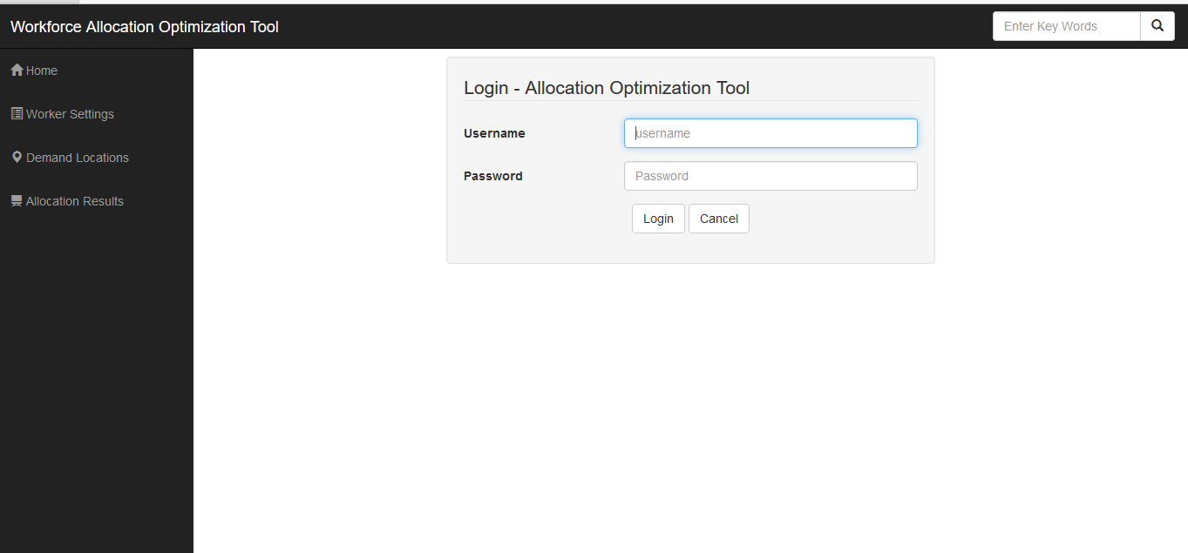
On the login page, enter the username and password to be able to access the system.
Note: for security reasons, do not allow your browser to save your password. Further information regarding security features can be found in the Workforce Allocation Optimization Tool Technical Specifications document

Home Page
The home page shows a dashboard with summaries of the data that are in the system. There are also some links to other sections of the tool, for example, input pages, i.e., worker settings and demand location.
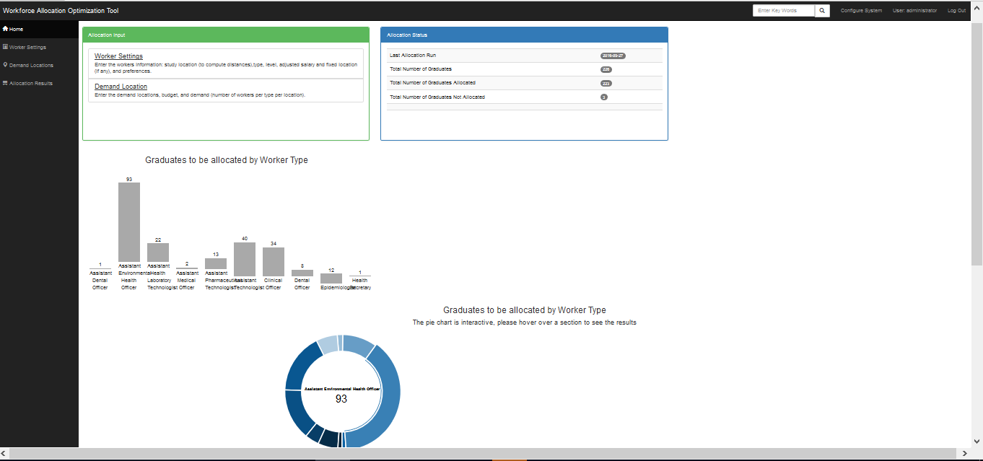

Worker Settings
This is where the graduates’ demographic and academic data are displayed in a listing. The preferences are also shown here. There are options to view or delete a graduate’s record.
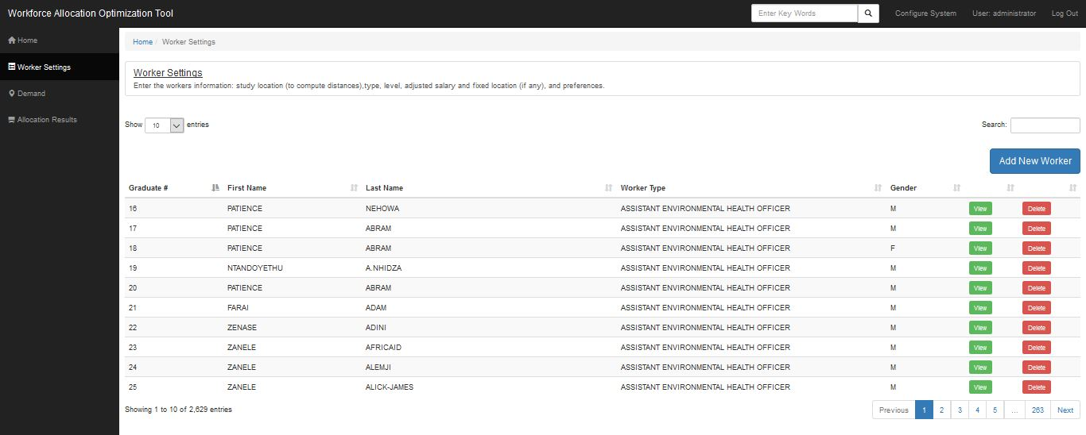
A new worker can be added to the list by clicking the “add new worker” button, which prompts the system to return the page displayed below.

Add new worker
The following screenshot shows the page used to capture the new worker’s details.
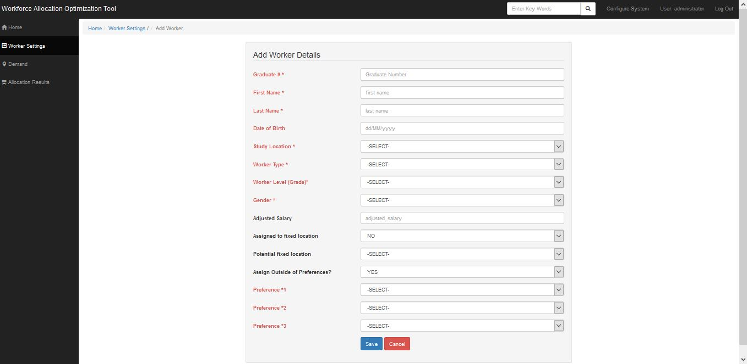

Demand
This presents a cross tabulation that shows demand locations in terms of the requested posts, and against worker types.
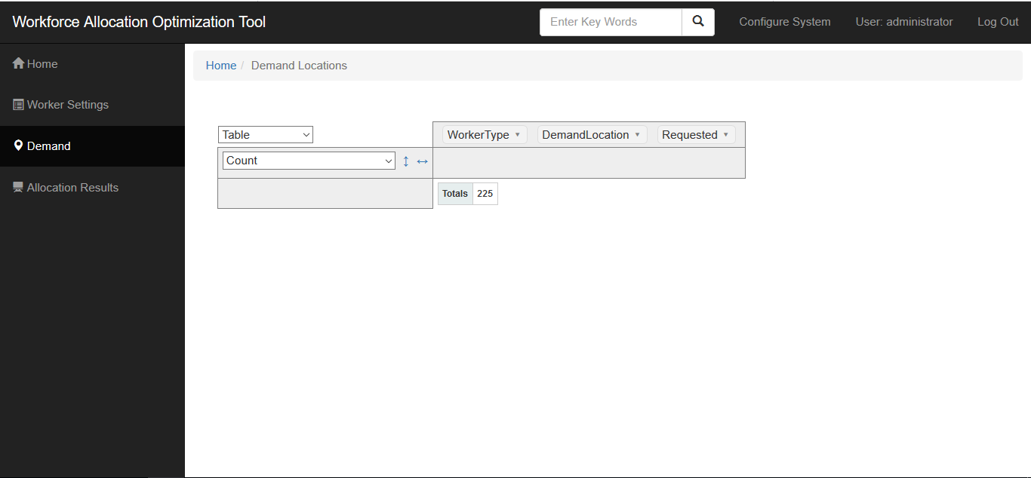

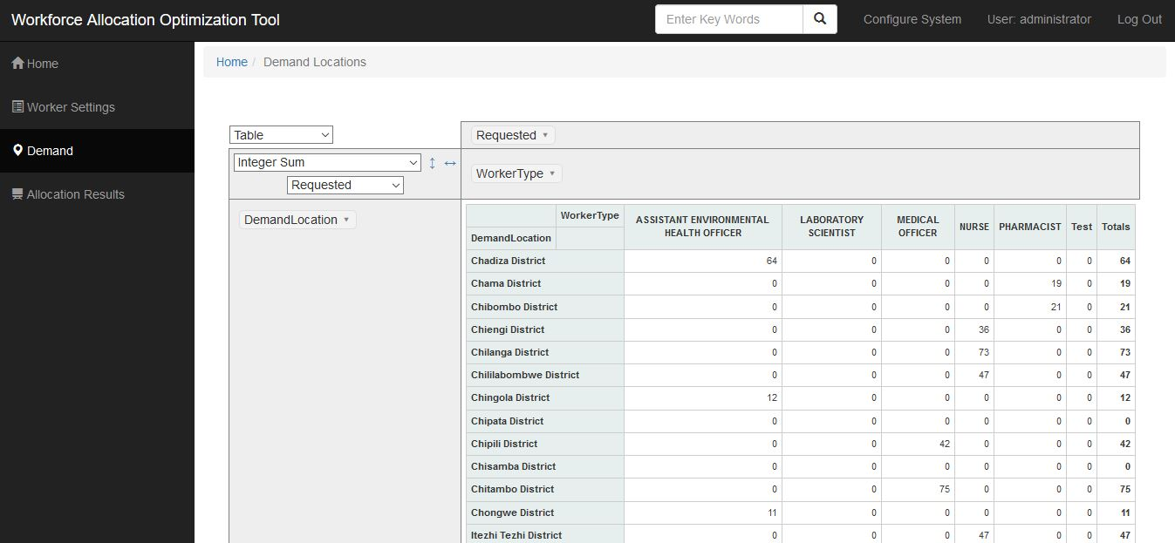

Configure System
There are links which will allow addition of input data that does not change frequently i.e. static data, for example the list of worker types, worker levels and Salary. Also available are links to run the allocation tool to produce some allocation results.
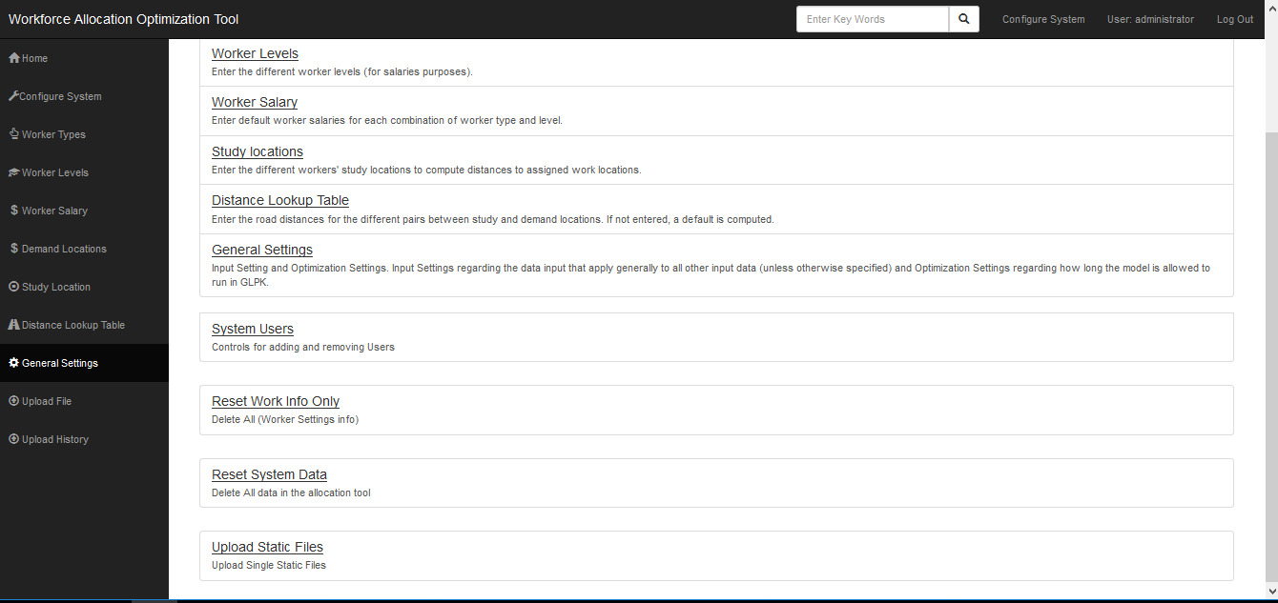

Worker Types
This page shows a list of all the cadres that are there, and these can be viewed and/or deleted.
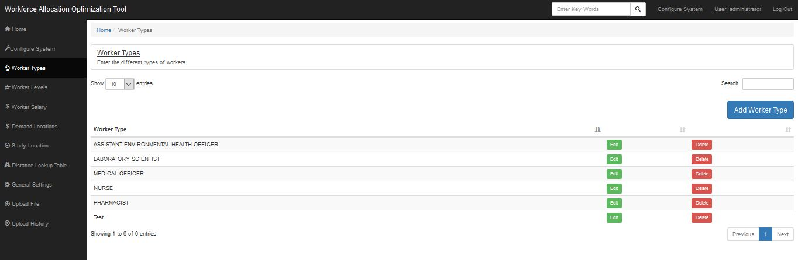
To add a new worker type, click on the “add worker type” button.

Add worker type
Enter the details required below to successfully add a new worker type, click save and return to the worker type page.
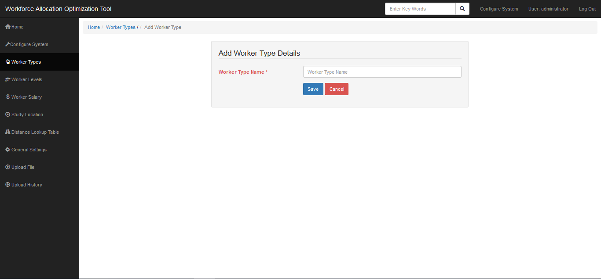

Worker Levels
Worker levels are the various ranks that a worker type may have. There are default worker levels that cut across all cadres. The worker levels page shows the list of worker levels, which can be edited or deleted.
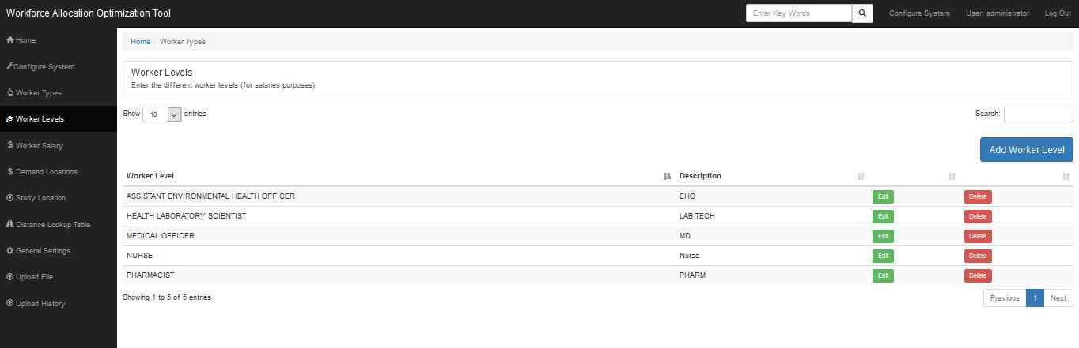
New worker levels can be added as well, by clicking “add worker level.”

Add worker Levels
Enter the details required below to successfully add a new worker level, click save and return to the worker level page.
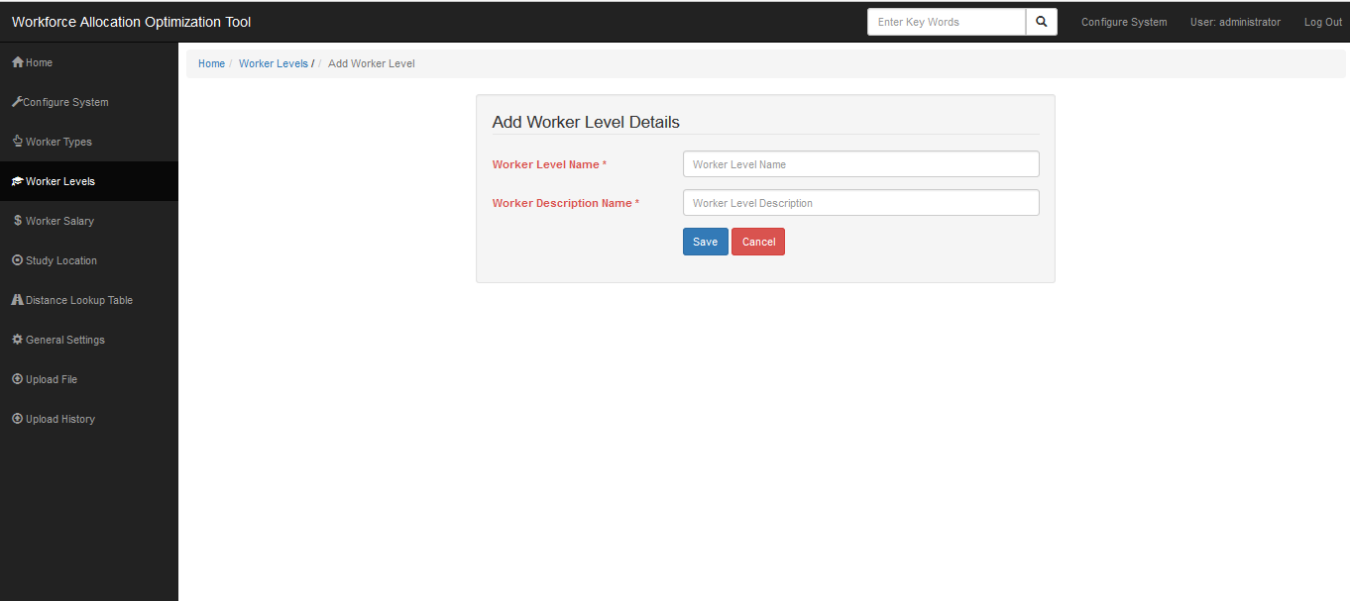

Worker Salary
Default salaries are captured based on the worker type, or a combination of both worker type and level. This page shows a list of all the possible salaries that are there, and these can be viewed and/or deleted.
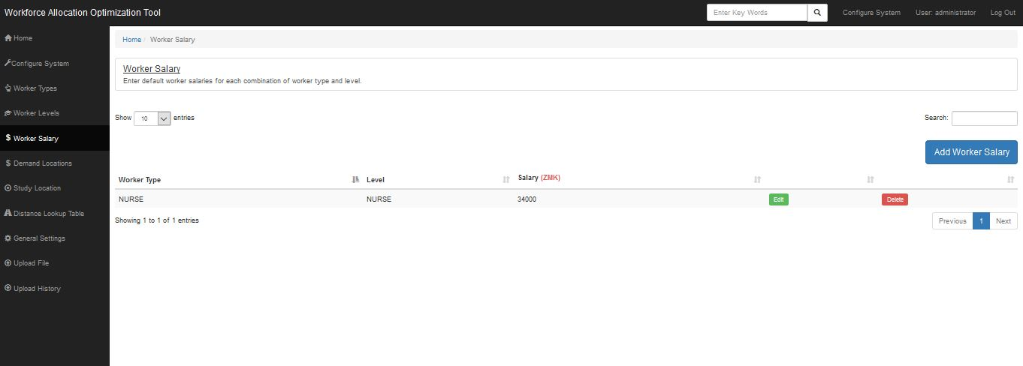

Add worker salary
Enter the details required below to successfully add a new worker level, click save and return to the worker level page.

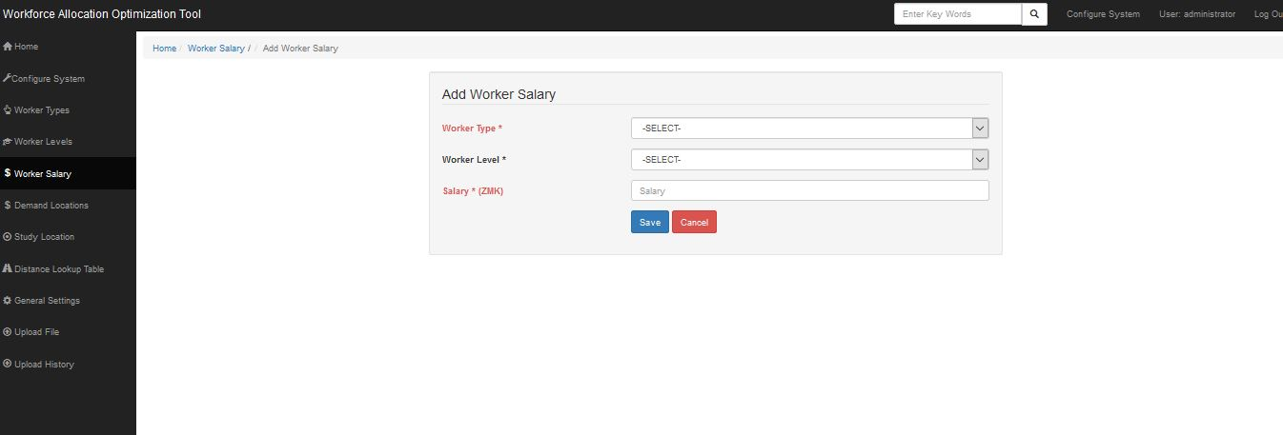

Demand Locations

Demand locations are those facilities or districts or provinces that have demand for health care workers. This is where the demand locations that are uploaded are viewed.
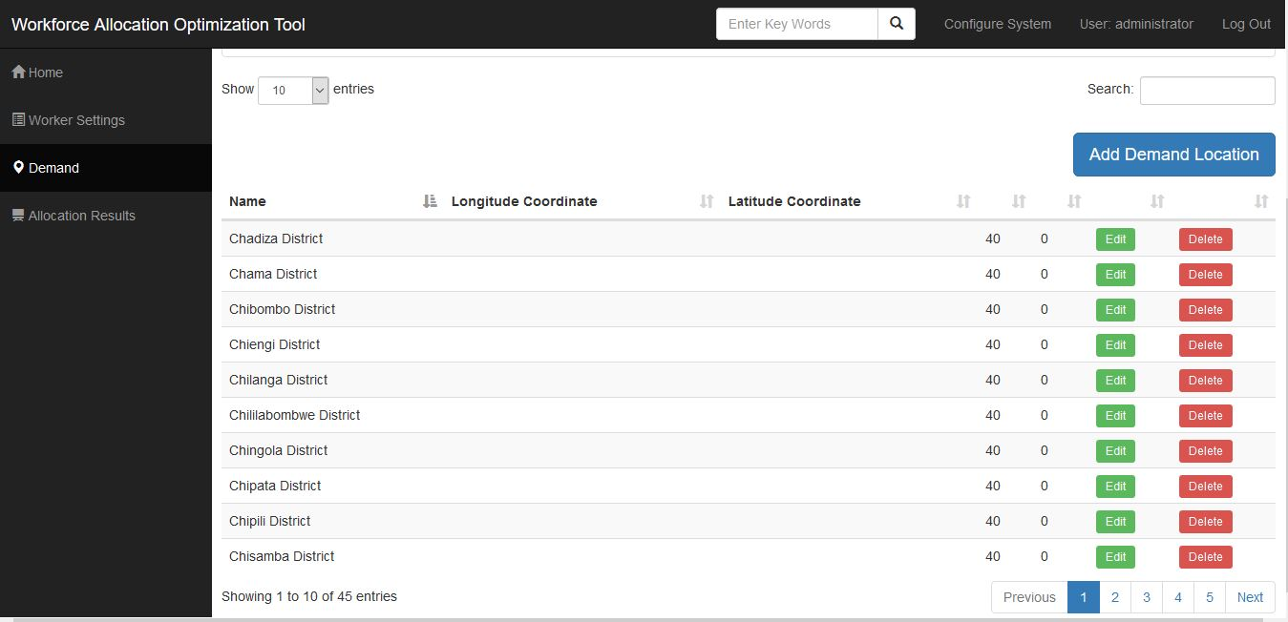

Add New Demand Location
Enter the details required to add a new demand location as shown in the screen below. The screen also gives you the platform to specify the number of requested personnel for each worker type for the new demand location.
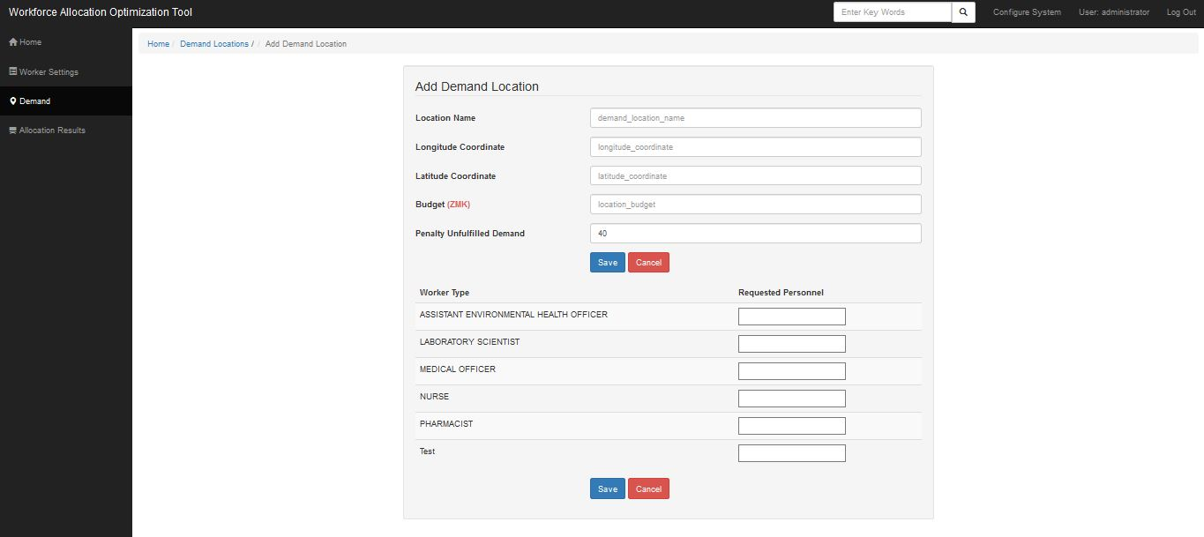

Study Location
Study locations are the training institutions that grant credentials to medical graduates. These locations are listed on the study locations page and these can be viewed and/or deleted. A study location may also be a demand location.
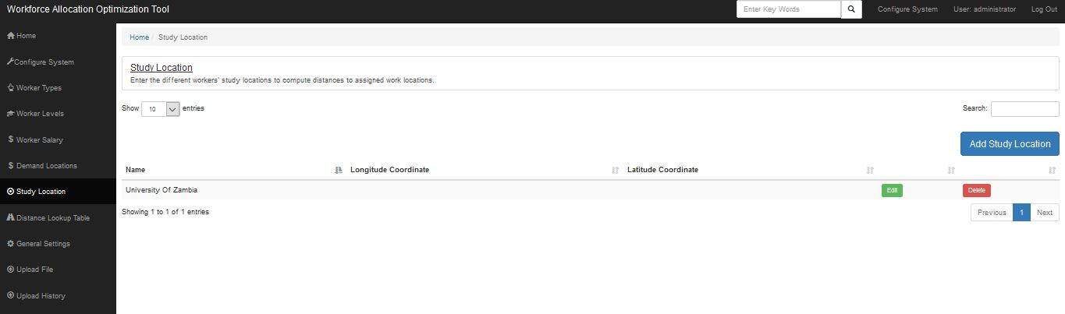

Add Study location
Enter the details required below to successfully add a new study location, click save and return to the study location page.
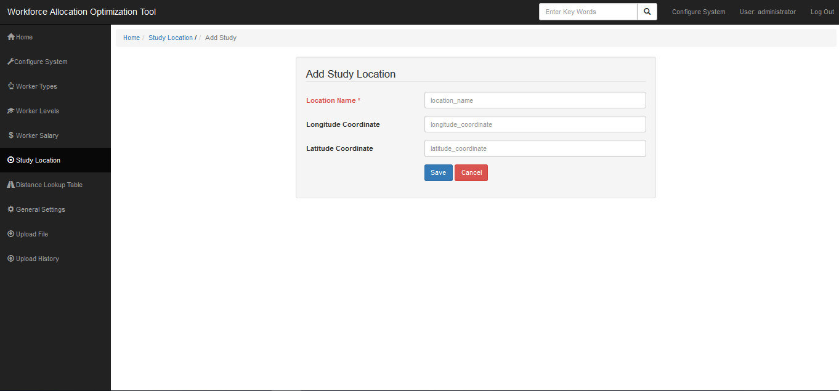

Distance Look up table
This page displays the distance in km between a study location and a demand location. The tool will map all possible study locations and demand locations, calculating the distance between them.
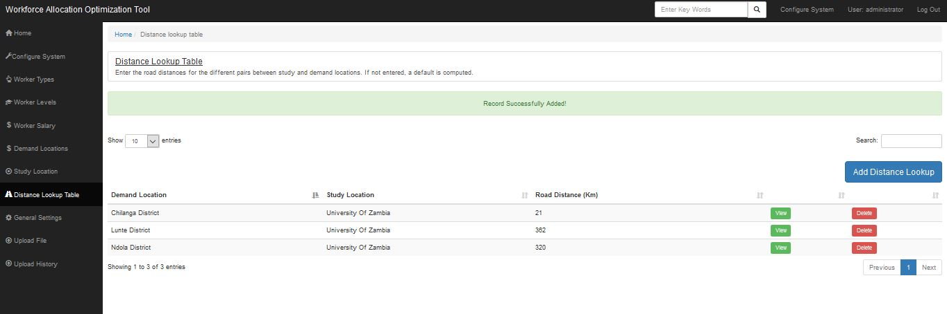

Add distance look up table
Enter the details required below to successfully add a new distance lookup record. Click save and return to the Distance lookup table page

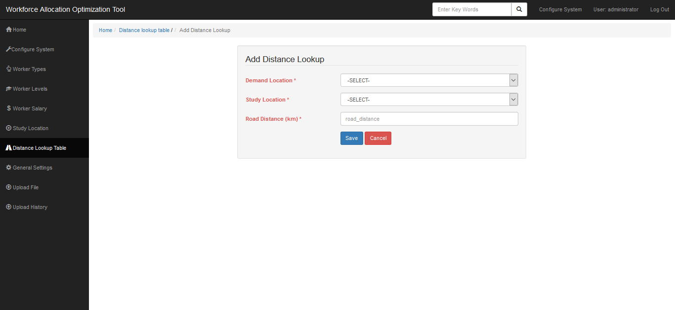

General Settings
There are some settings on the system constraints that require pre-setting before running the allocation tool and these include the maximum run time, number of preferences allowable, total budget and the currency in context.
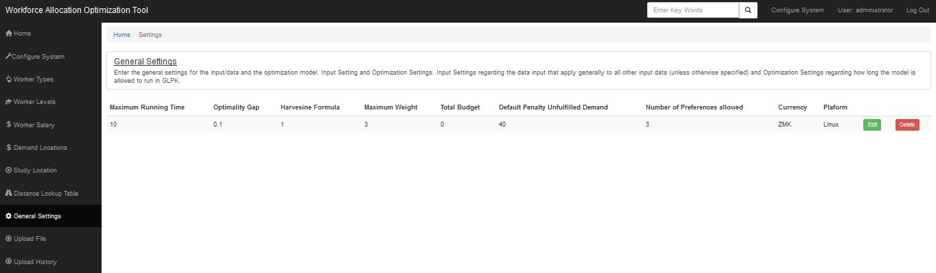

System Users
This page shows all the system users. These can be deleted or edited. New users and user groups can be created. User groups are roles on the system which determines the functionalities that a specific user can do within the system.
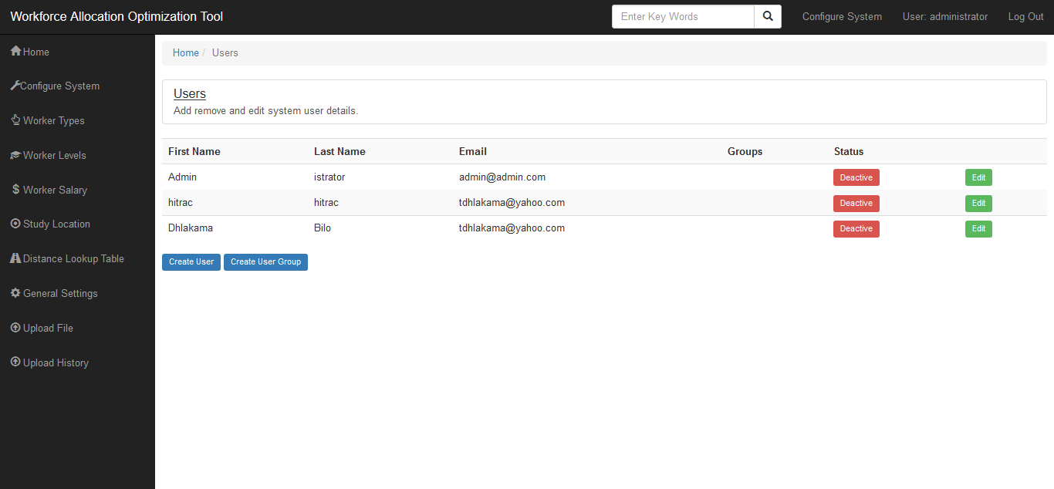

Create system user
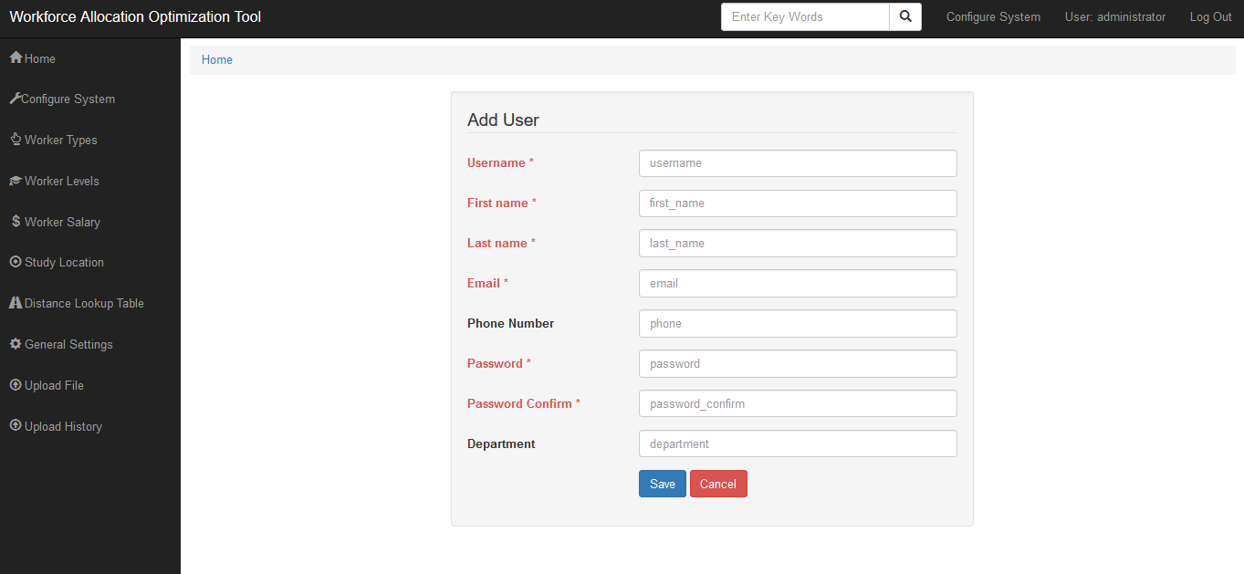

Allocation Export
This allows the download of data files in CSV format. “Generate Data Files” allows a download of a zip folder with all data files. Other links allow the download of specific data files.
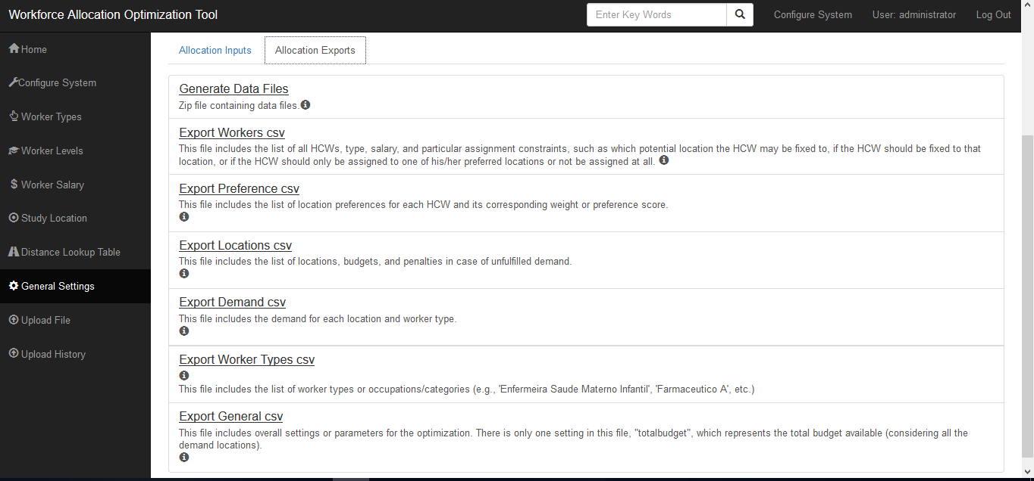

Upload file
Sometimes graduate data may be uploaded in batches—e.g., a list is presented on an Excel file, and the Excel sheet is uploaded into the tool. One has to download the Excel template first from the page below and populate it with the desired data, and then upload the file again.
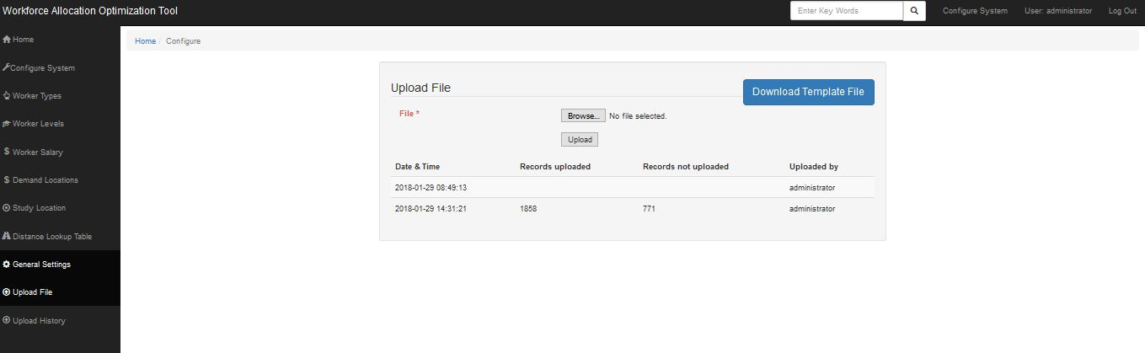

Upload History
This page shows a list of all the uploads that have been done on the tool. It gives details, such as the date and time, who uploaded, and the records uploaded and those not uploaded, specifying the upload failure reasons.
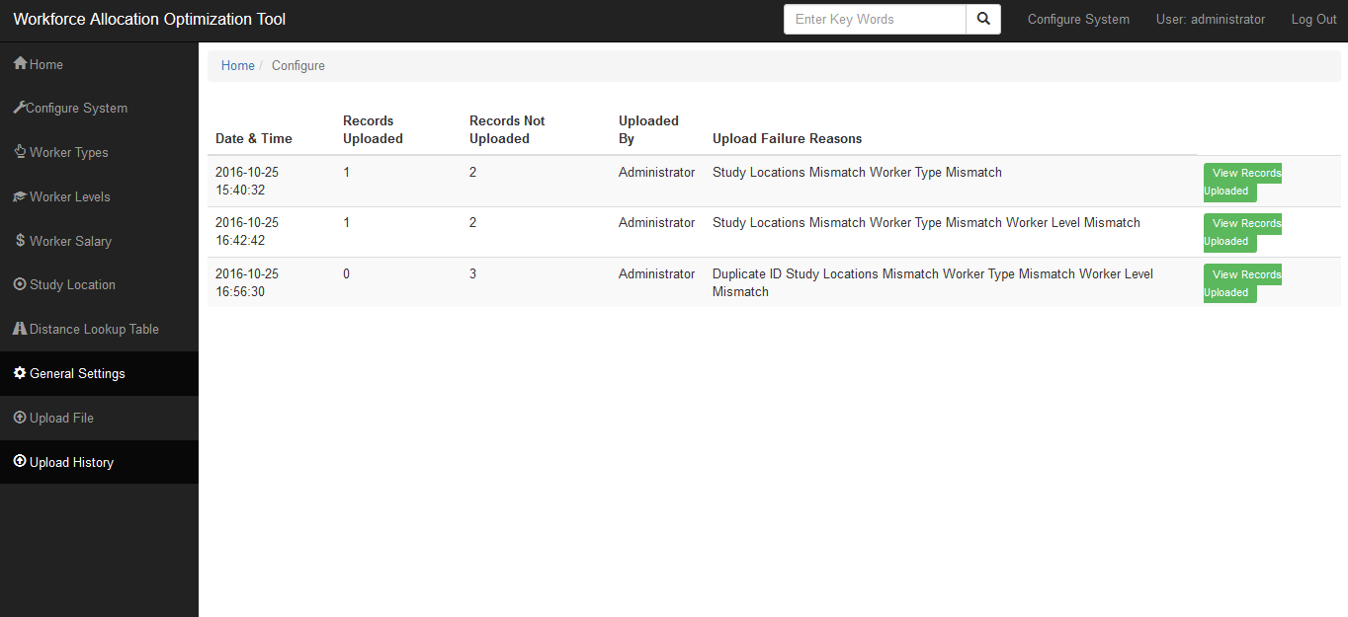

Run GLPK
This is the processing of all the allocation input to produce results. On the allocation results page, click the tab that reads “Run GLPK,” and the tool will process the data in the background.

Allocation Results
Clicking on “Allocation Results” will prompt the system to return the page in the figure below, which shows links to all the output files.
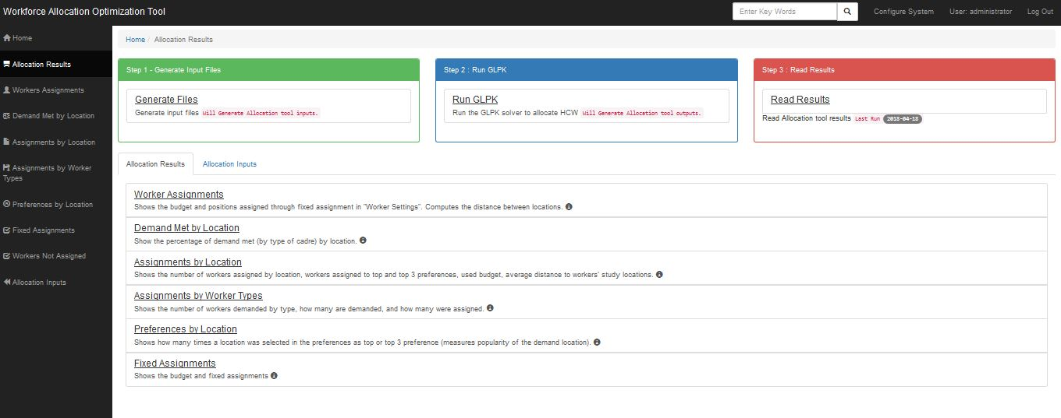

Worker Assignments
The page below shows the list of health care workers and where they have been assigned.
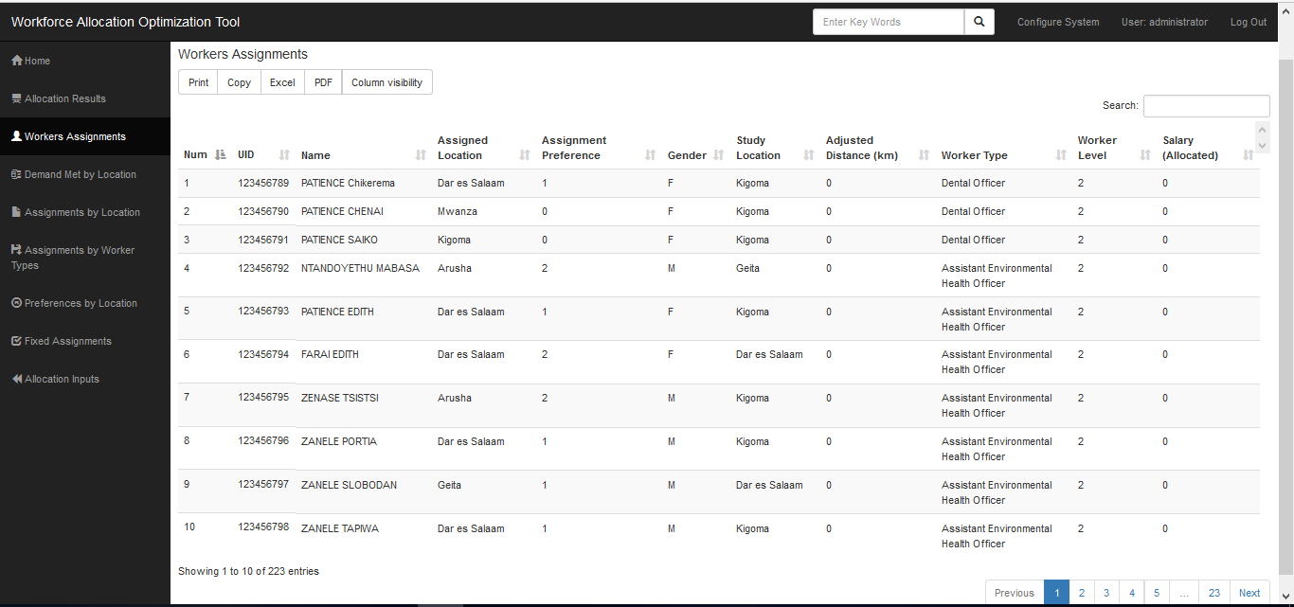

Demand met by Location
Shows the percentage of demand met (by worker type) by location. The results are presented in a cross tabulation and various maps can be used to depict trends of the demand met. The following examples shows a heat map where a deeper red shows the worker type where the higher values of allocation were, and the lighter the red the less the values allocated to that worker type.
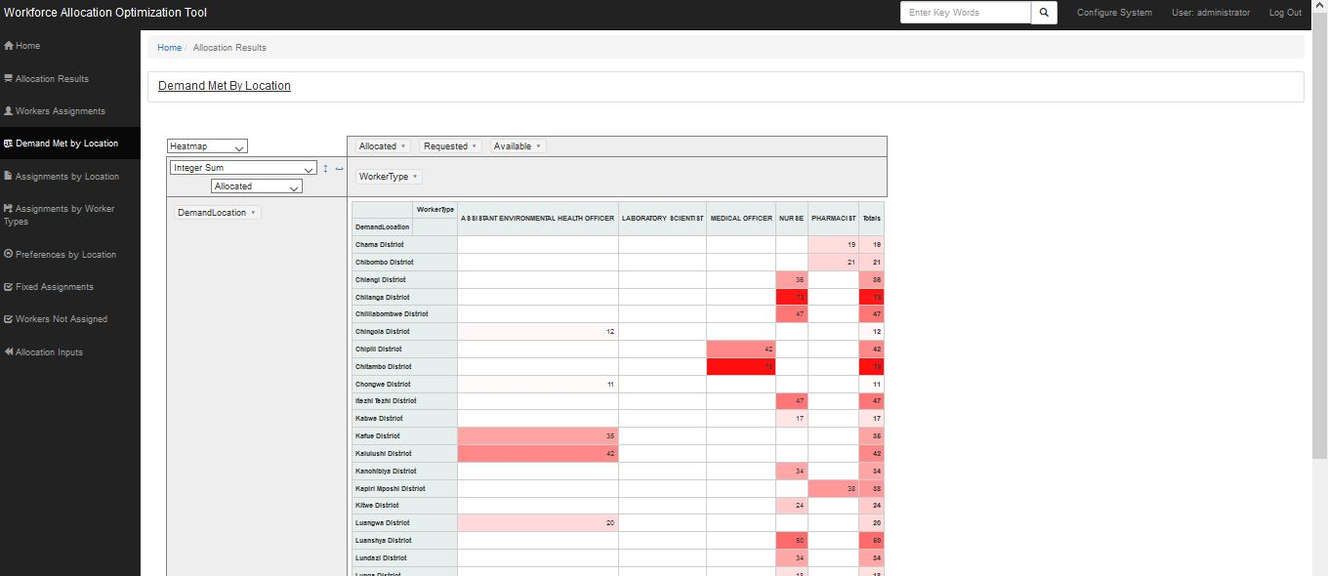

Assignments by Location
Shows the number of workers assigned by location, workers assigned to top and top-three preferences, used budget and average distance to worker’s study locations.
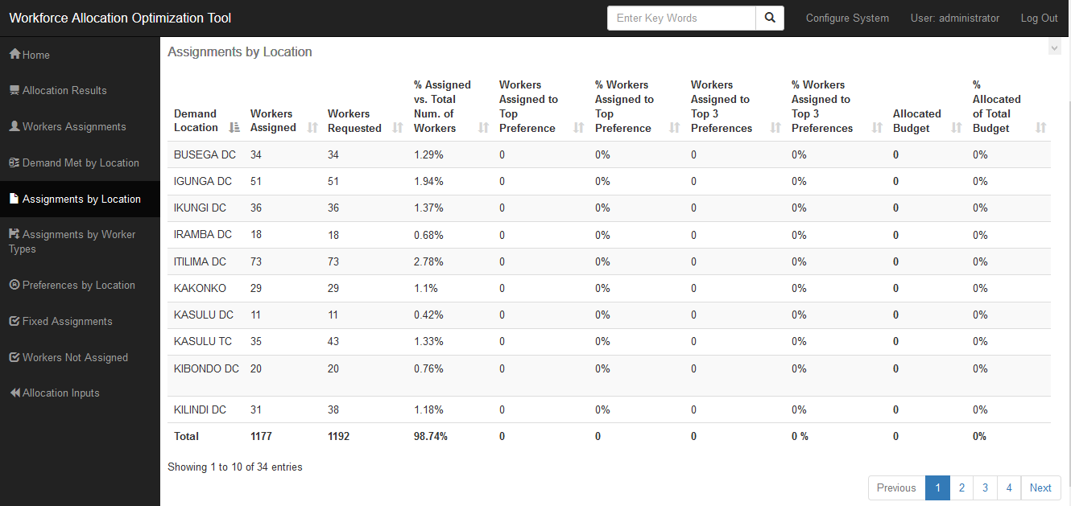

Assignments by Worker type
Shows statistics of the assignment results for each worker type (and overall for all worker types at the top). This worksheet can help to compare the total demand for each worker type, with the available number of workers of that type. This can help adjust demand data if necessary.
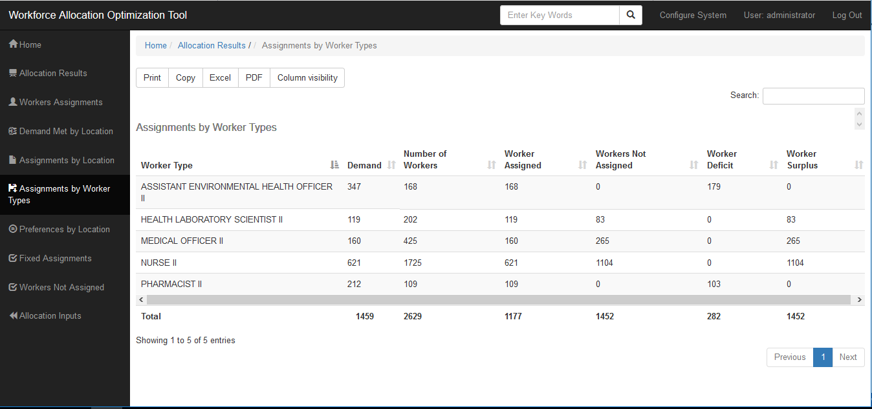

Preferences by Location
Shows how popular a demand location is in terms of how many times the HCWs selected them as a top or top-three preference.
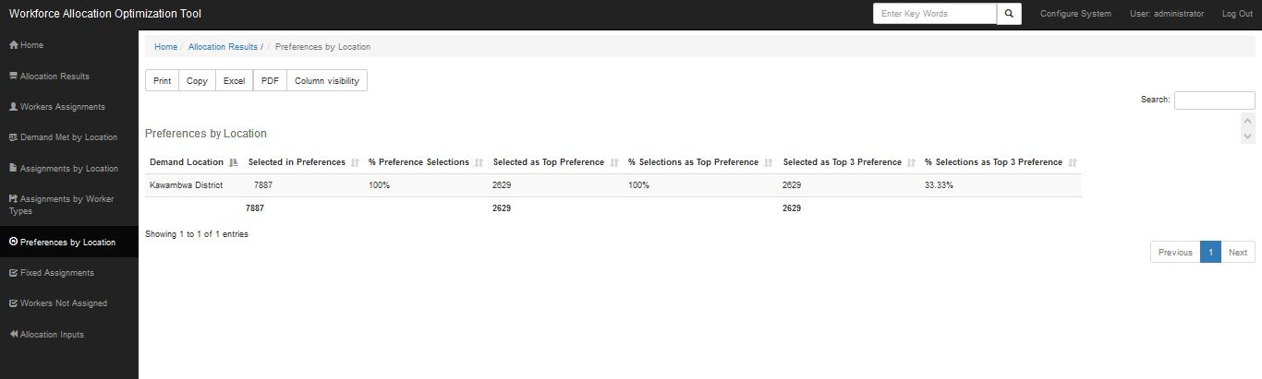

Fixed Assignments
A location may request that a certain health worker be assigned there. The location will be flagged as the workers potential fixed location. Upon running the allocation process, the tool will not consider all other options but will automatically assign to that location. A report of all the fixed allocations is then displayed on the page below.

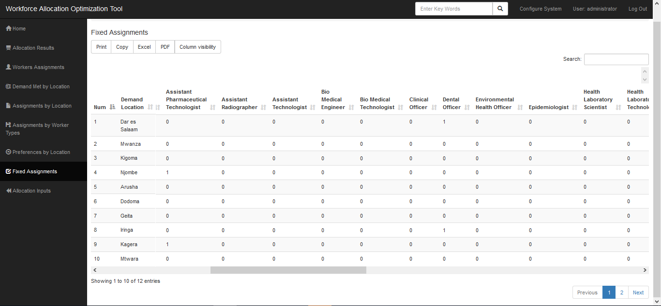

Workers Not Assigned
Shows the list of health care workers not assigned to any demand location.
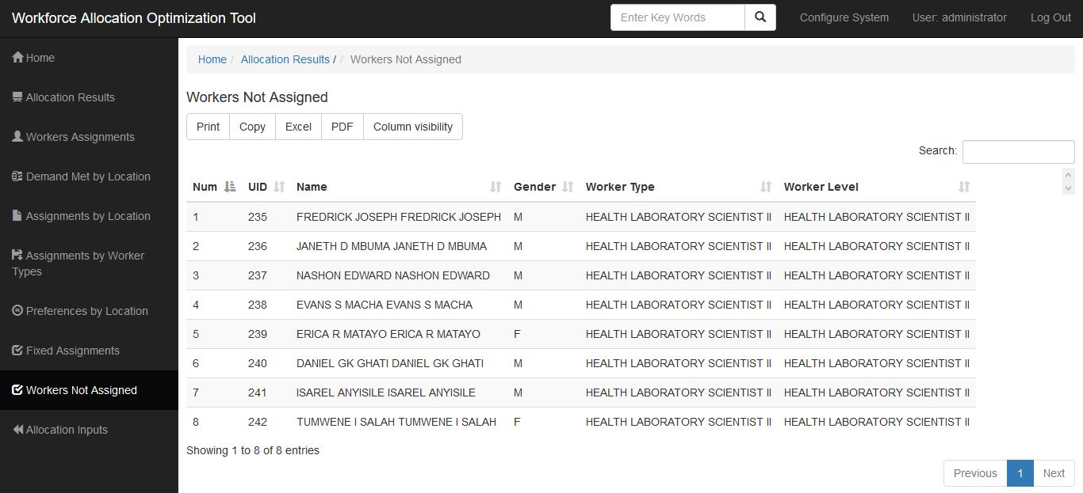

Universal Search
The universal search allows users to search for anything from any file in the system. Start off by typing in a search keyword in the search box on the top navigation bar.
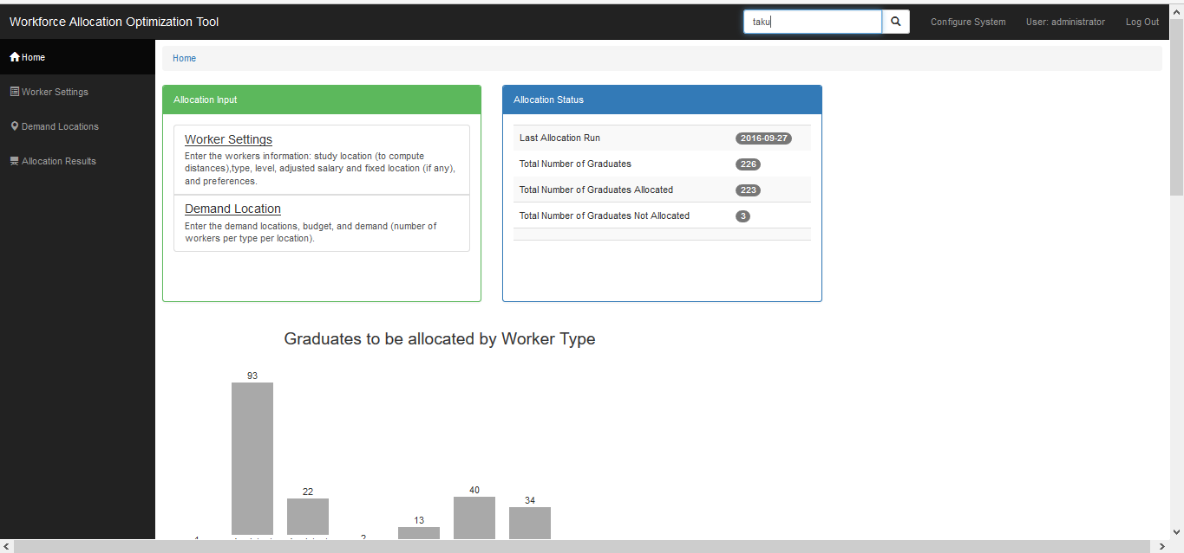
The whole system will be searched, and results will be displayed in various categories, which reflect different sections of the system as shown in the image below.
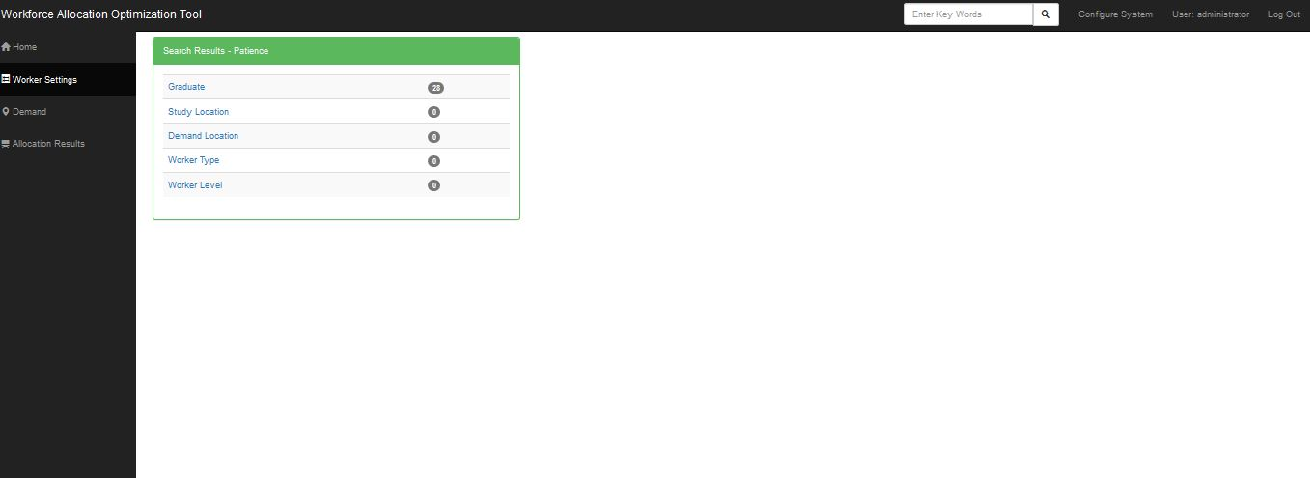
If a user selects a particular category, then the tool will expand and show all records that match the search under that category. The user can then select the actual record (s)he wants.
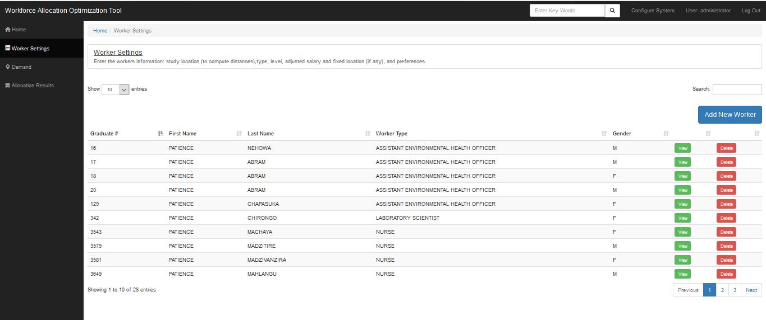

Log out
On the top right corner of the tool, there is a log out button, which, when clicked, will prompt the system to request that the user confirms log out. Once the user confirms that (s)he wishes to log out, the tool redirects to the login page.
Further details can be found in the Workforce Allocation Optimization Tool Technical Specification Document. Additional Information includes how to run and configure the system and/or troubleshoot some technical glitches that may be encountered.
----- end-----

